Text Area: | 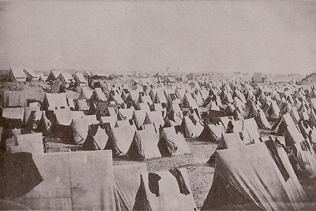  A Sea of Tents: Soldiers’ Homes  Text Area:

